# **How to Quit Your Job**

**Zoe's avatar**

[Zoe](https://substack.com/@zoeffc)

Sep 06, 2024

Share

Hi guys!

Exciting news! I just finished my first week in a brand new job. I am beyond excited to be switching from my previous role to this one for so many reasons. Mostly though, I am thrilled to be growing and advancing in my career. However, to start a new job, you have to leave your current job.

In this week’s note, I want to share some best practices for leaving your job. Wildly enough, our media has painted a truly fictional notion of quitting. I beg of you, do not shout at your boss or list all of the shitty things they did. This is not The Office.

First some housekeeping:

📫 If a friend forwarded you this newsletter (then you have some really cool friends), and you may want to consider joining us [*here*](https://femme-futures.beehiiv.com/subscribe) for regular updates.

[Subscribe](https://femme-futures.beehiiv.com/subscribe)

🧲 Got some thoughts you want to share? Join us on [*Discord*](https://discord.gg/592wuyvx?utm_source=femme-futures.beehiiv.com&utm_medium=referral&utm_campaign=how-to-quit-your-job) to chat all things newsletter and corporate life.

[Discord](https://discord.gg/N84WxemQ?utm_source=femme-futures.beehiiv.com&utm_medium=referral&utm_campaign=how-to-quit-your-job)

You can find all archived newsletters at the online site, if you ever want to go back or if you just feel like perusing.

[Check out the website](https://femme-futures.beehiiv.com/)

**Do’s:**

1. **Look for a new job before leaving your current job.** I have left a job without having another lined up before and I would not recommend it. However, if you need to get out of a toxic situation, it is your best bet. That is why I say to *look* for a new job. That doesn’t necessarily mean that you have a job lined up, but I want you to get a sense of what is out there for you. Get a sense of the market. Get a sense of what the jobs that you are interested in require. Update your resume. Most importantly, start imagining your next step.
2. **Tell your manager.** This is dependent on the relationship that you have with your manager. I found that in my most recent transition, having my manager be aware that I was in final round interviews was helpful. It made my new team more comfortable about hiring me, allowed my new manager to talk to my old manager, and made the internal transfer a lot less drama-filled. That being said, if you do not have a good relationship with your manager (it happens), DO NOT TELL THEM BEFORE YOU HAVE SIGNED YOUR CONTRACT. Skip this step and proceed to step three.
3. **Write a letter of resignation.** This is the part that no one really explains. This is not a place to give your manager/team/company a piece of your mind. This is extremely formal and should contain no emotion whatsoever. If you are sad to be leaving, have that conversation in person, allow that relationship the respect of a proper farewell. If you are thrilled beyond belief to be getting out, DO NOT PUT THAT IN YOUR LETTER. This should be perhaps the driest email that you have ever written in your life. Here’s a template:

Dear [manager name],

I am writing to formally notify you of my resignation from my position as [title]. My last day of work will be [full date]. In the time between today and that date, I will be implementing a transition plan to ensure that processes continue to flow upon my exit.

[Optional paragraph about what you will be doing next.]

I appreciate the opportunities for professional growth and development you have provided me during my time here. Thank you for your support and guidance.

Sincerely,

[You]

1. **Clean up.** If you are anything like me, your file organization makes perfectly logical sense to you. Hell, you could tell anyone ten different ways to find one particular document from 6 months ago. That’s great while you are *in* the role, but now, you need to make sure that your systems and structures make sense to someone who has never once understood those explanations you gave, isn’t going to remember that you made a transition plan, let alone refer to it, and just needs that one thing immediately. Idiot-proof your systems.
2. **Take a second to reflect.** Jobs are hard. Shit happens that doesn’t feel good. Some shit happens that makes you feel like everything you do matters and thank god you are in a position to make this impact. My sister reminded me that while I have had to navigate some truly atrocious behavior in the workplace, I have also had to deal with standard, run-of-the-mill, work shit, and have had some good moments throughout. Allow for the complexity. Take a deep breath. Keep going.

**Don’ts:**

1. **Don’t talk shit in public.** My ability to stay professionally polite in public is what has kept me landing new roles. I would love to go as far as to say, don’t gossip and don’t complain. But I cannot say that. Gossiping and complaining to a couple of confidants has kept me sane time and time again. In situations where you are being gaslit or bullied, being able to confide in someone alleviates the isolating nature of the treatment. That being said, choose your confidants wisely. They should be people that you trust not to spread word of your feelings to the wrong ears. As I move into my new role, I am trying to reduce my habit of bitching and moaning. I think that in so doing, I will allow for more joy in my relationships as they will stop being quite as centered on the negative.
2. **Don’t be passive-aggressive.** Once you have your out lined up, all that matters is that you keep showing up as the best possible version of yourself. There is a light at the end of the tunnel. There is a new chapter just about to begin. Leave this current situation in a way that you are proud of. Your impression of how it ended is all that matters. (And don’t make enemies… that doesn’t help you in the long run.)
3. **Don’t take on new projects.** *Okay, overachievers?* If you cannot finish the project before you leave your role, do not take it on. If you absolutely must participate, ensure that you are not the only one working on it. This is your transition plan — figure out who will take on each of your projects and ensure that they have what they need to do so.
4. **Don’t burn it all down.**

Leaving a job is emotional. Sometimes it requires that you grieve the role’s inability to meet your expectations. Sometimes you grieve leaving a team that you truly love. Change is hard. Growth is hard.

My last tip is for myself: let a fresh start be a fresh start.

Love,

Zoe

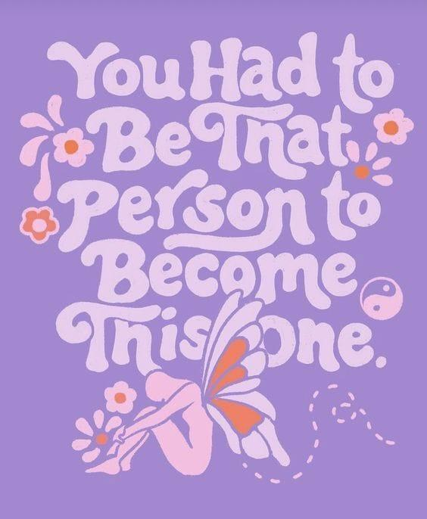

*artist unknown*

**Femme Futures Cooperative Founding Principles**

💚**Mission**: The mission of Femme Futures is to create a community space for young professionals who identify as over-achievers and activists to generate collective success by providing resources and platforms to thrive in challenging workplace environments.

💙**Vision**: To contribute to a world where driven individuals are equipped with the tools, guidance, and connections to overcome systemic barriers, fully utilize their talents, and enact positive change in their organizations and communities.